iPayTotal Hosted Page

API Documentation

This is iPaytotal Hosted Page API documentation. In this API, users details will be sent to iPaytotal server with curl request, whereas Credit card details page will be loaded over iPaytotal server. Follow bellow steps to integrate hosted page API with iPaytotal.

1. Send Curl request

Curl request send with bellow parameters. Some parameters are optional but we recommend to send with request. All personal details should be of credit card holders. User here used for credit card holder.

|  |  |  |  |
| --- | --- | --- | --- |
| **Parameters** | **Data Type** | **Required** | **Description** |
| api_key | String | Y | API key from iPaytotal account |
| first_name | String | Y | First Name of user |
| last_name | String | Y | Last Name of user |
| address | String | Y | Address of user |
| country | String | Y | 2 letter Country, eg US |
| state | String | Y | State Name, 2 letter for US states, eg CA |
| city | String | Y | City name |
| zip | String | Y | Zip code |
| ip_address | String | Y | IP address of user device, eg 94.104.7.296 |
| birth_date | String | N | Birth date of user |
| email | String | Y | Valid Email address of user |
| phone_no | String | Y | Phone number |
| amount | Decimal | Y | Amount value |
| currency | String | Y | 3 Digit format, eg USD |
| response_url | String | Y | Merchant site URL where we redirect from 3DS complete if transaction will be success or fail |
| sulte_apt_no | String | N | Order number of Merchant Transaction |
| webhook_url | String | N | Merchant site post URL where we send webhook notification. |

Request URL: **https://ipaytotal.solutions/api/hosted-pay/payment-request**

Testing URL: [**https://ipaytotal.solutions/api/test/hosted-pay/payment-request**](https://ipaytotal.solutions/api/hosted-pay/payment-request)

Request type: **POST**

Response:

After successful request, response will be sent in JSON format.

Successs Json Response type :

**{**

**“status”:"success”,**

**“payment_redirect_url”: "**[**https://ipaytotal.solutions/hosted-pay?hash=gVRC9OjvYehEbiTAS7RXoxC7L1566046455**](https://ipaytotal.solutions/hosted-pay?hash=gVRC9OjvYehEbiTAS7RXoxC7L1566046455)**”,**

**"api_key": "sugQdpk3gwNi9x63MRAFLgkMJ4nyil88ZYMyjqTSE3FIo8Lghfi",**

**"sulte_apt_no": null,**

**“valid_till”:"2019-08-08 02:51:02”**

**}**

If the request data is in valid format, then above response will be sent. You will be need to redirect to **“payment_redirect_url”** for payment page before **“valid_till”.**

If there will be validation errors in request, response will be like:

**{**

**"status": "fail",**

**"message": "Some parameters are missing or invalid request data.",**

**"errors": {**

**"country": [**

**"The country field is required."**

**],**

**"state": [**

**"The state field is required."**

**]**

**},**

**"sulte_apt_no": null,**

**"api_key": "api_key"**

**}**

1. Redirect to payment_redirect_url

After you redirect to url payment_redirect_url, bellow form will be loaded over iPaytotal payment page. You will need to fill credit card details

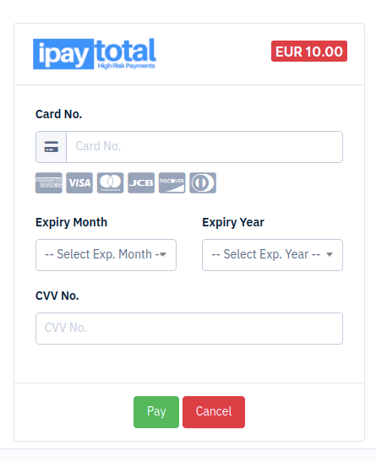

If making request in testing URL, then it will ask for Credit card details. Use this bellow testing card data

**Testing Card data**

card_no: **4242 4242 4242 4242**

Expiry Month: **02**

Expiry Year: **2021**

CVV Number: **123**

card_no: **4000 0000 0000 0077**

Expiry Month: **02**

Expiry Year: **2021**

CVV Number: **123**

1. Response from iPaytotal

After Credit card form fill up, user need to press Pay button. This request will take some time, if user card has 3D secure feature enabled, it will also redirect to 3D secure page, where user will asked to input PIN or OTP if asked. After all process complete, user will be redirect to merchant website according to transaction status.

If transaction will be success, user will redirect to ”response_url” with response in query string as bellow:

https://ipaytotal.solutions/success?status=success&message=Your%20transaction%20was%20success&order_id=20190000458521&sulte_apt_no=456789521365

If the transaction will fail, user will redirect to “response_url” with response in query string as bellow:

https://ipaytotal.solutions/fail?status=fail&message=Activity%20limit%20exceeded.&order_id=20190000458521&sulte_apt_no=456789521365

**Webhooks:**

If "webhook_url" parameter is send with the request payload, then we will send notifications of every transaction to the merchant website server at "webhook_url". The request will be send in json format.

Below is the webhook request example:

**{**

**"order_id": "202095632606577891",**

**"sulte_apt_no": "TS4565",**

**"transaction_status": "success",**

**"reason": "Transaction success",**

**"currency": "USD",**

**"amount": "12",**

**"test": true,**

**"transaction_date": "2020-06-03 12:01:45"**

**}**

**Request explanation:**

order_id: IPaytotal transaction order ID.

sulte_apt_no: Merchant transaction order ID.

transaction_status: Transaction status - "success"/"fail"

reason: Response from the bank about transaction.

test: Transaction environment in test mode. - true/false